# QUIZ 2 - RANDOMISATION TEST

## Question 1

Below is the output from iNZight of a single re-randomisation comparing the difference between the two group means.

See also the information in the introduction to this Quiz [(previous page)](https://www.futurelearn.com/courses/data-to-insight/4/quizzes/155875/introduction).

[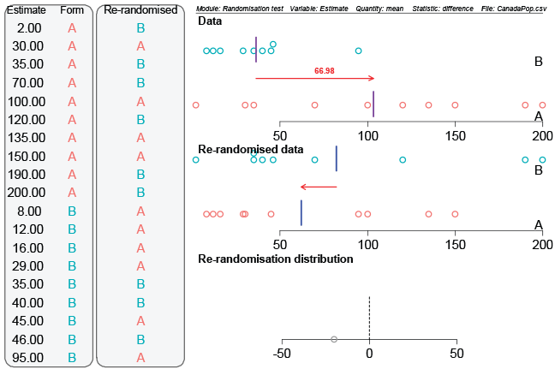](https://flexiblelearning.auckland.ac.nz/data-to-insight/7/2/images/quiz1b.png)

Select the statement that is **FALSE**. (Recall that the units are millions.)

For the **re-randomisation** shown, the *Re-randomised data* plot shows that the “Group A” mean is about 20 million less than the “Group B” mean.

To do one re-randomisation, the real A and B group labels are removed, and then 10 people are randomly chosen from the 19 available to be relabelled with “A” and the remaining 9 are relabelled “B”.

The person in (real) Group A with an estimate of 200 (million), was re-labelled Group “B” for the re-randomisation shown.

In the data, the mean of the estimates Group A people gave for the population of Canada was about 67 million smaller than the mean estimate Group B people gave.

**Correct**

This statement is **FALSE** – The difference in the answer is back to front. The top graph is the data from the experiment. The red arrow shows the difference between the two group means with the mean of A (vertical line) **larger** than the mean of B.

## Question 2

Parte superior do formulário

This is a continuation of the previous question.

Here is the output from the end of the Randomisation test animation from VIT for testing for a true difference between the group means of Groups A and B.

[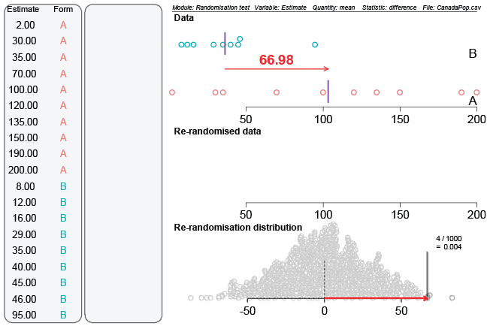](https://flexiblelearning.auckland.ac.nz/data-to-insight/7/2/images/quiz2b.png)

Select the statement regarding this output that is **FALSE**.

The **Re-randomisation distribution** is made up of the differences between the Group “A” and Group “B” means for 1000 re-randomised data sets. Each dot in the dotplot is the difference in group means from one of the re-randomised data sets.

An observed difference of about 67 million or more only occurred in 4 re-randomisations out of 1000.

**It makes no difference which form of question the researcher asks. Our Re-randomisation distribution shows that the difference between the group means occurred because of the luck of the randomisation draw.**

When we just rely on the “luck of the randomisation draw” we almost always get a difference in group means which is smaller than the experimental difference of 67 million.

Correct

This statement is **FALSE** – Random re-assignment almost always gave us values smaller than our observed difference of 67 million.

Parte inferior do formulário